**Reference Link:** <https://www.microsoft.com/en-us/download/details.aspx?id=39717>

* **Click on the above link to download the latest IR**

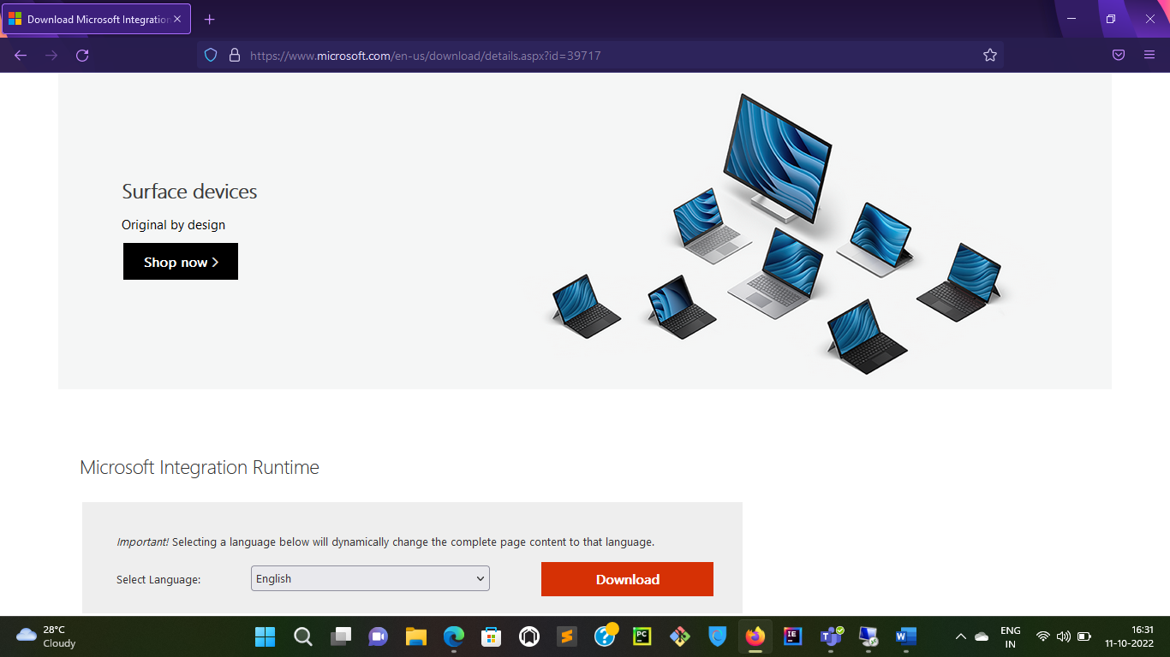

* **Once you click on download you will see this page**

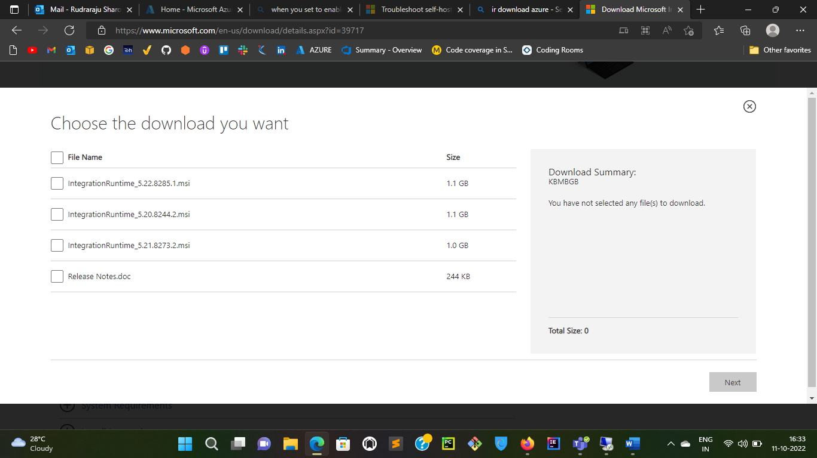

* **Download Release Notes.Doc to see which version is latest and what are improvements made**

These are the three versions of IR currently available to download from Microsoft:

IntegrationRuntime_5.22.8285.1.msi – (Latest version)

IntegrationRuntime_5.20.8244.2.msi

IntegrationRuntime_5.21.8273.2.msi

# Introduction

Microsoft integration runtime is a client agent that enables cloud access for on-premises data sources within your organization. With integration runtime, you can copy data from on-premises data sources to cloud and vice-versa. You can also use it to scan your on-premises data sources for metadata extraction and classification.

# CURRENT VERSION (5.22.8285.1)

* What’s new –
  + Microsoft Purview: added support for scanning SQL Server on Azure Arc-enabled servers.

# EARLIER VERSIONS

## 5.22.8297.1

* Security fix–
  + Fixed a security vulnerability in process communication.
* Known Issues –
  + Web activity might fail with NullReferenceException

## 5.21.8273.2

* What’s new –
  + Microsoft Purview: added support for scanning Power BI using service principal authentication.
* Bug fix:
  + Self-hosted integration runtime does not work properly after auto-update in some cases.
  + Azure Data Factory: fixed an issue that pre-copy script failed to run for Microsoft Access connector
  + Azure Data Factory: Sap Odp fix the type converting issue when extracting INT8 type data
  + Azure Data Factory: Sap Odp support SNC mode without SSO
  + Azure Data Factory: fixed the issue in Script Activity where the incorrect AAD endpoint is hit in sovereign clouds

## 5.20.8244.2

* Enhancement –
  + Microsoft Purview: service improvement on identity and token handling.